we need to download POSTMAN from
https://www.postman.com/
and click download the app button
https://www.postman.com/downloads/
After installing Postman the UI looks like this
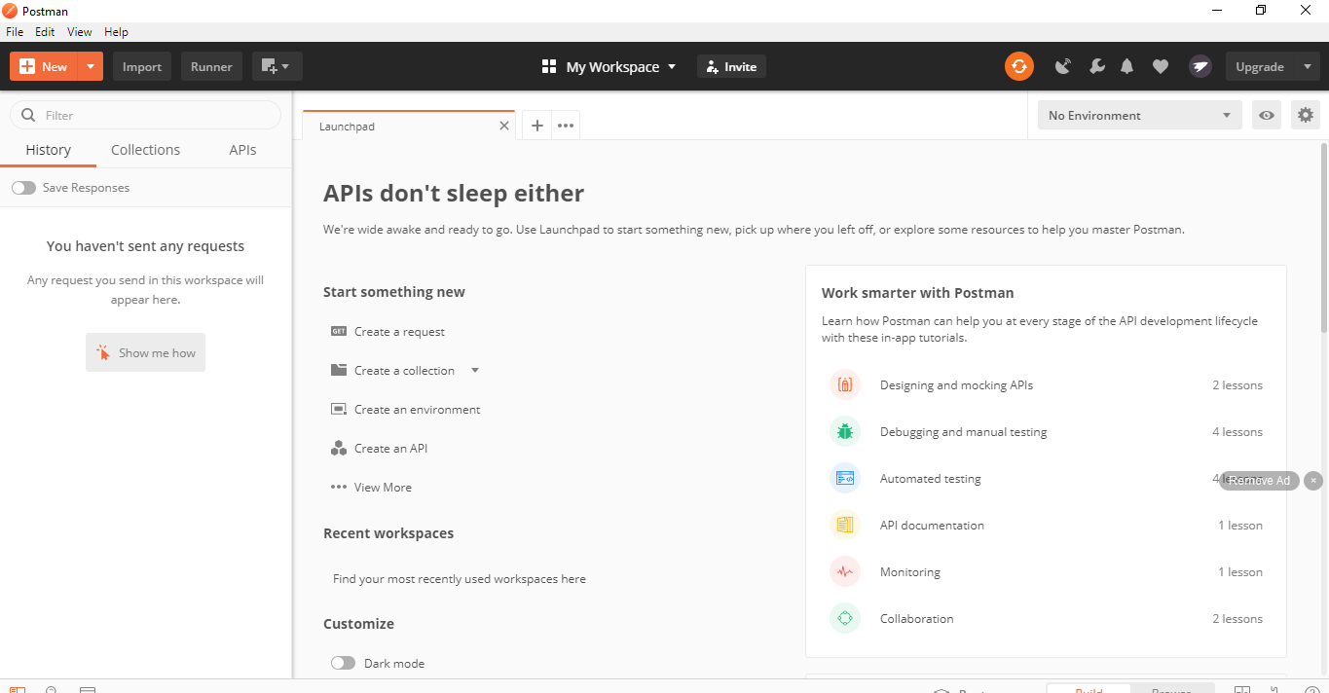
Navigate to https://rahulshettyacademy.com/#/practice-project
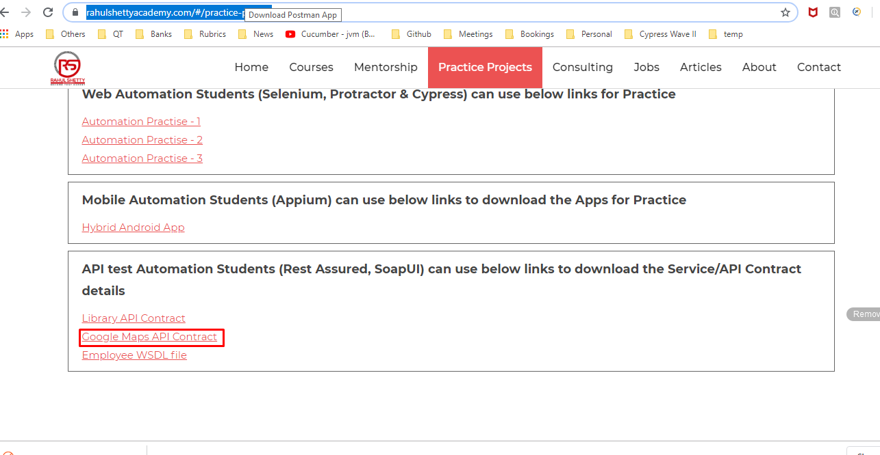
To start the API Testing, we need to get the Contract of the API.

Contract in sense, what is the
- Base url
- Resource
- Query Parameters
- HTTP Method
- JSON/ XML Body - how it looks like
- Response you are expecting.
All the above details are required before starting the API Testing.
In Postman App lets start testing API,
Click on New Collection and enter the Name of the Collection(which is like a folder name)
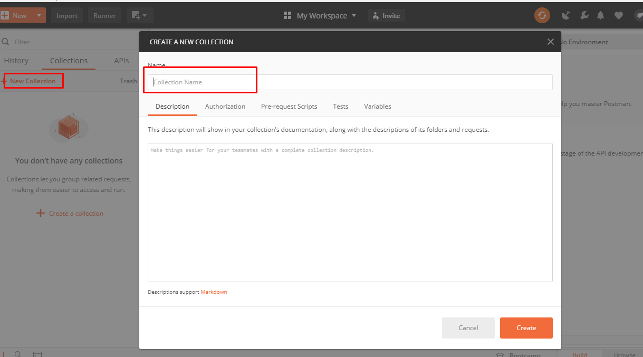

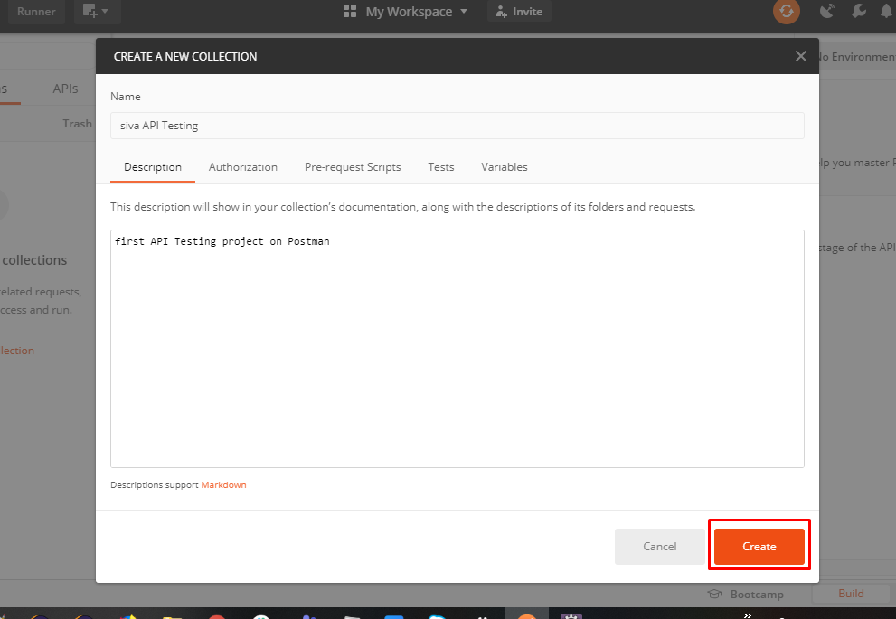
Collection got created successfully
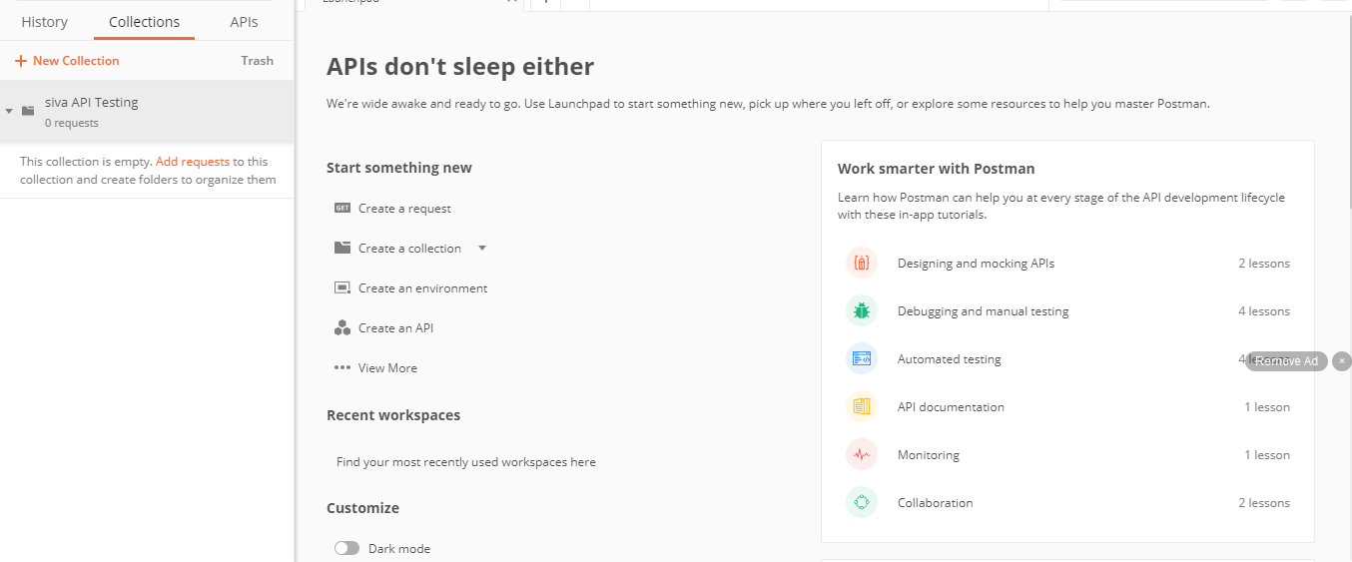
We click on Add Request to send Request to an API
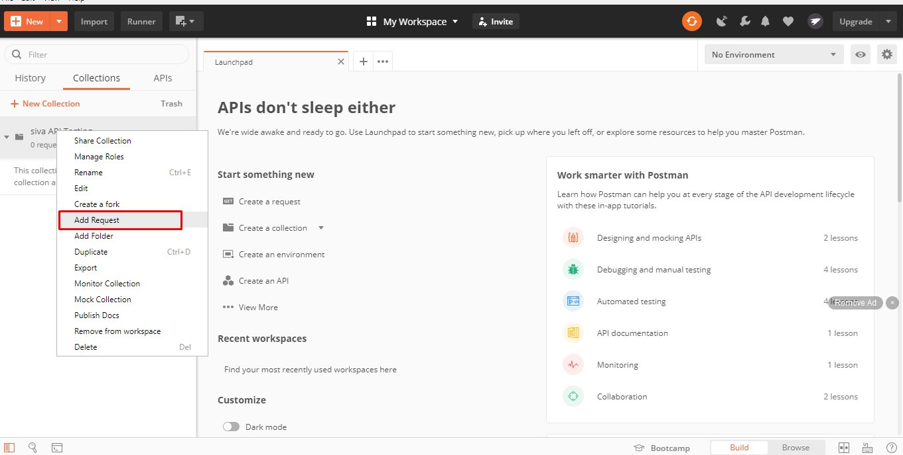
Given the Collection an apt name
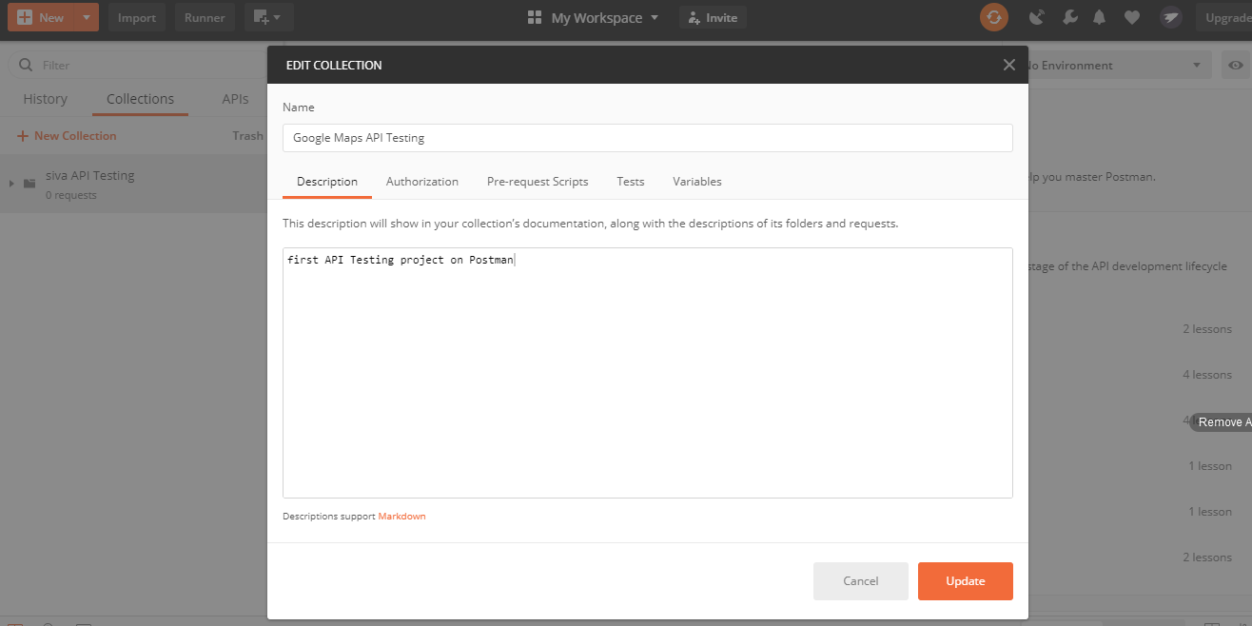
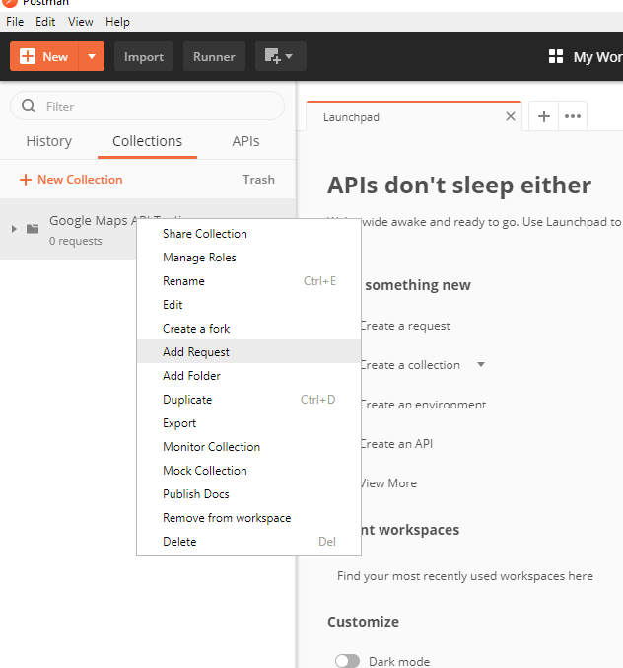
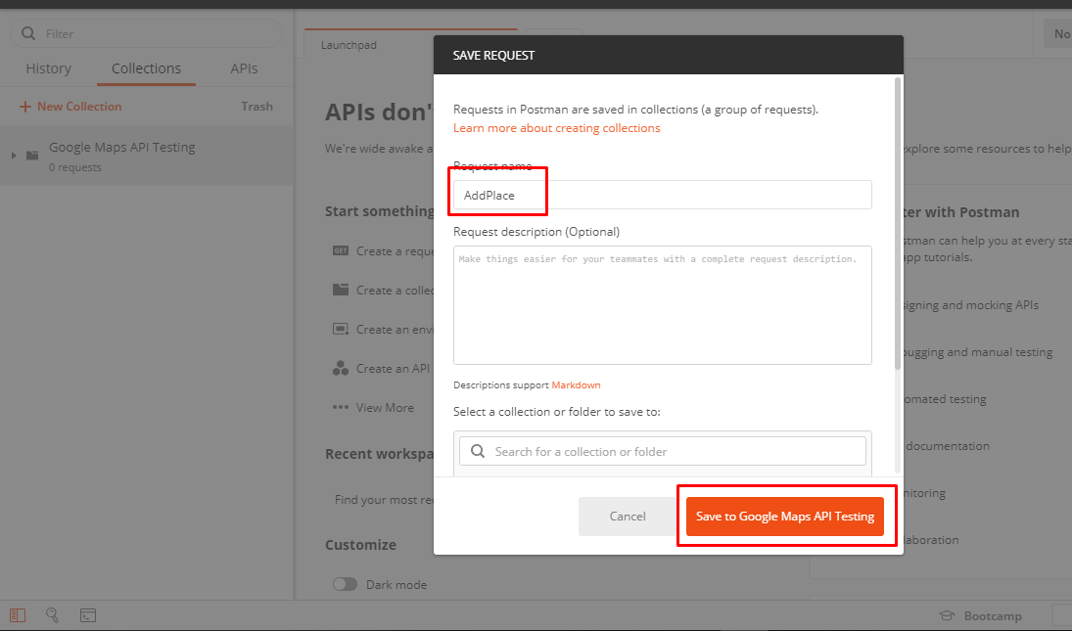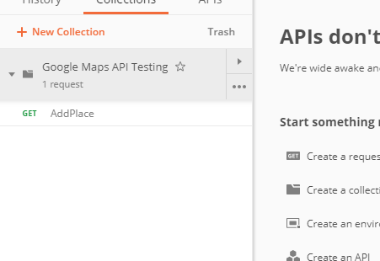
In below, we need to fill all the details and click on send button, so that request is submitted to api with the details we provided.

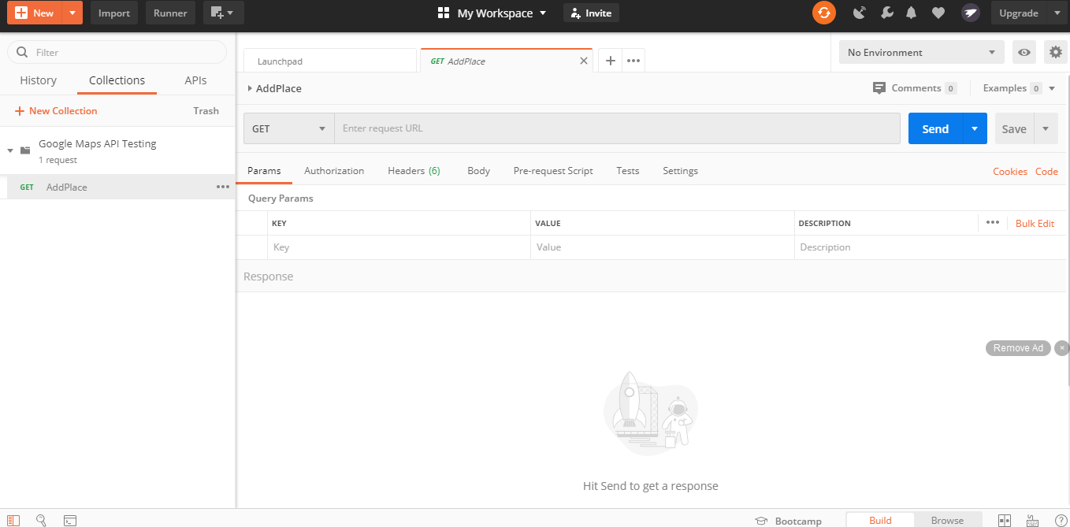
As we are adding new details into the Server, we need to use POST Method,
Base url, Resource are given
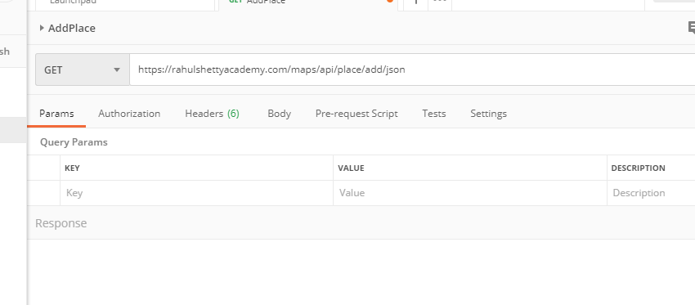
Now we are giving the Query parameter
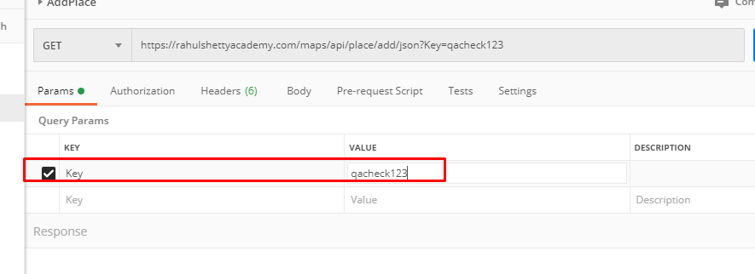
As we are going to POST into Server, we need to change the dropdown value to POST, you cant make a GET payload into POST, the developer will give that information.
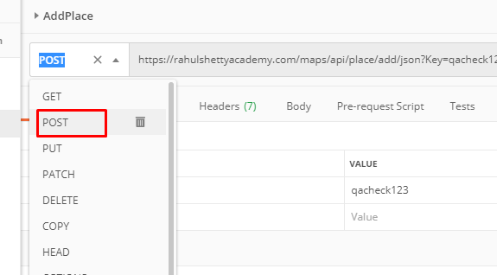
For this POST function, we need to add a body and clearly tell what needs to be added to the server URI which we are pointing to
As it is a POST Request, we need to send all the the required parameters, all these details should be sent securely in the body.
If it is a GET Request, you can send in URI itself, either in the form of Query or Path Parameter.
We need to know the format of the JSON.
99% all the payloads are JSON, we need to select Body, put the POST Request content, Select JSON from the Dropdown
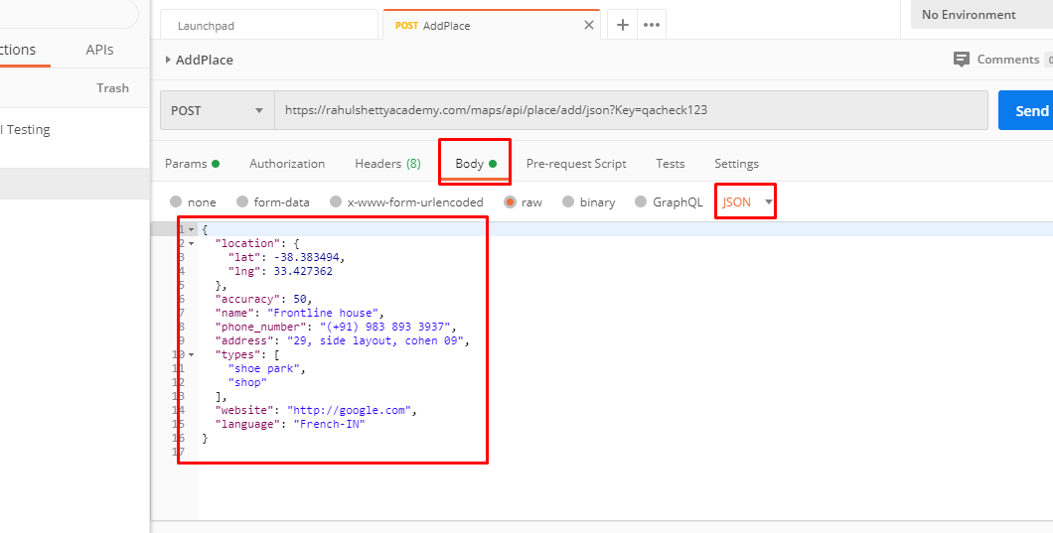
Content type is automatically set as json based on the payload
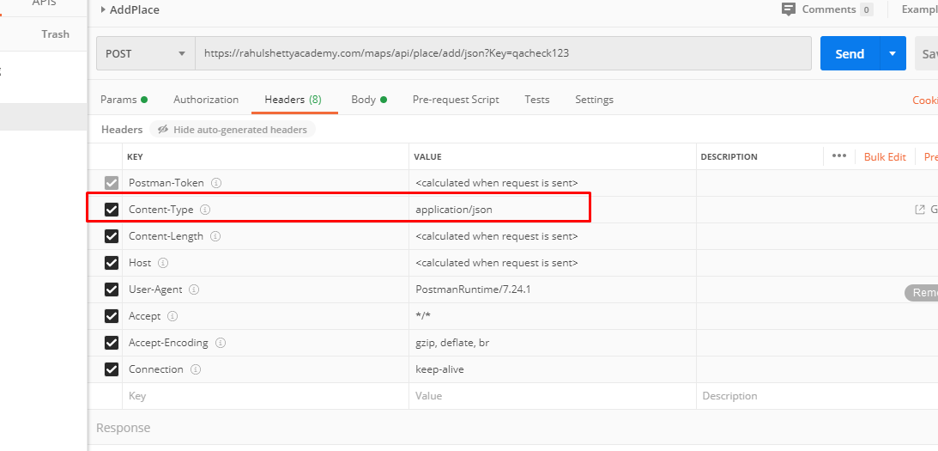
Click on Send response. Expected response will be generated. Eg. Place id
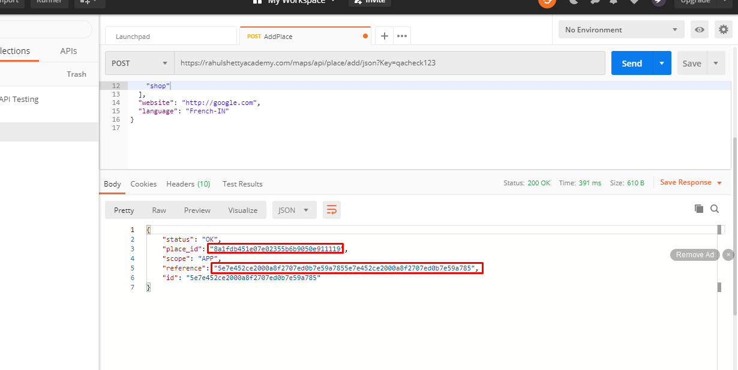
Status 200 OK - means Successful HTTP response recieved.

